**Task Description:**

Create a docker file, docker-compose file which when executed must display your basic details on the website.

**Step 1: Create an index.html to display the basic details about me on the website**

**Step 2: To create server.js file – A basic Node.js server that serves the HTML file**

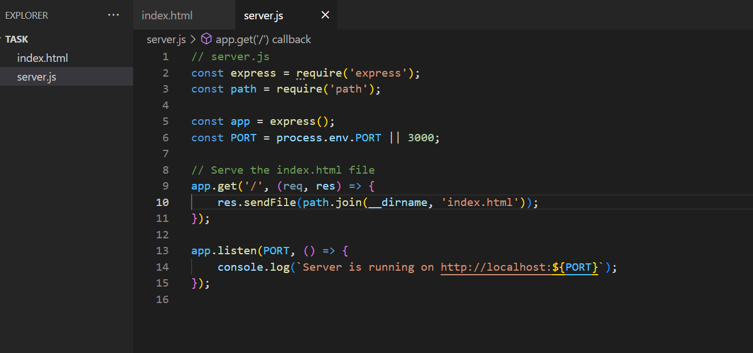

**Step 3: npm install – package.json file creation for dependencies**

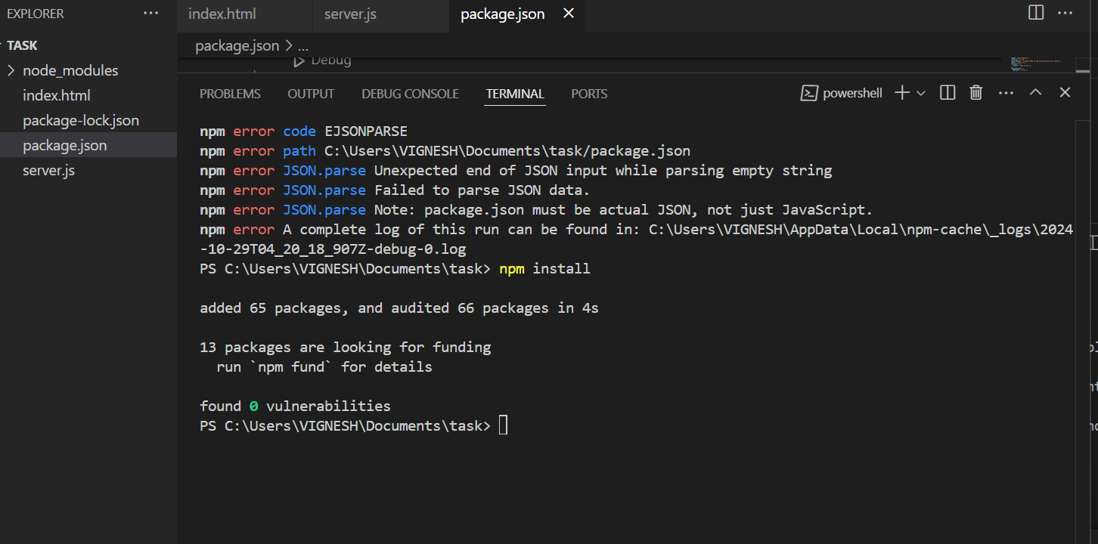

**Step 4: To create a Dockerfile with node js image**

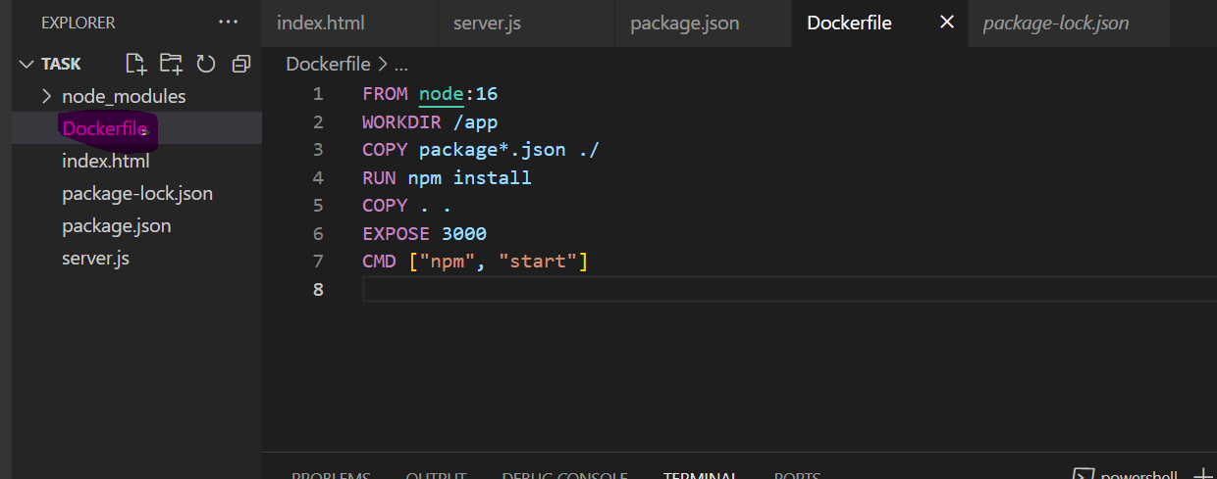

**Step 5: To create docker-compose.yml file for service configuration**

**Step 6: To build and run an image**

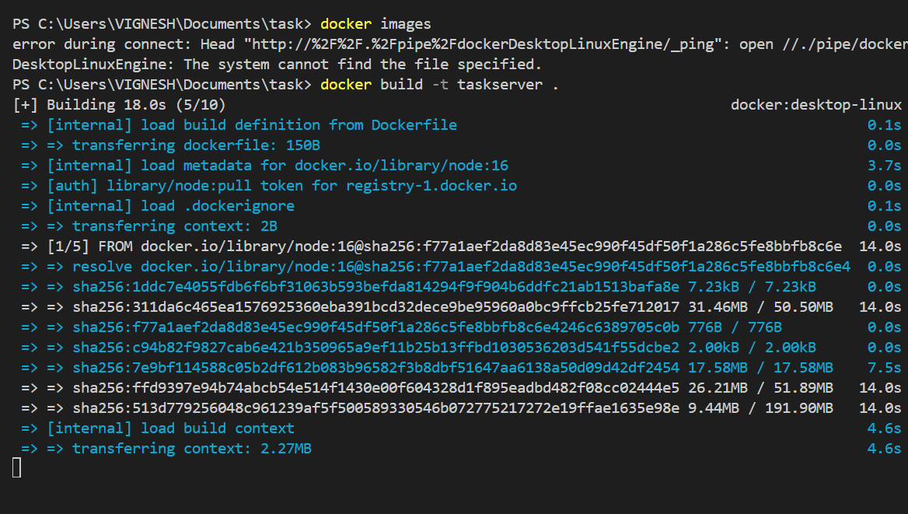

**Step 7: Image tag and push**

**Step 8: Launch an instance in EC2 in aws with Amazon linux 2023**

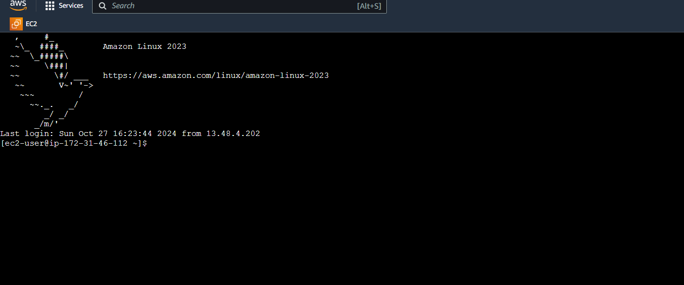

**Step 9: update pacakage manager and docker version and docker compose file**

~ sudo yum update -y

~ sudo amazon-linux-extras

~ sudo service docker start

~ sudo usermod -a -G docker ec2-user

~ sudo curl -L "https://github.com/docker/compose/releases/download/1.29.2/docker compose-$(uname -s)-$(uname -m)" -o /usr/local/bin/docker-compose

~ sudo chmod +x /usr/local/bin/docker-compose

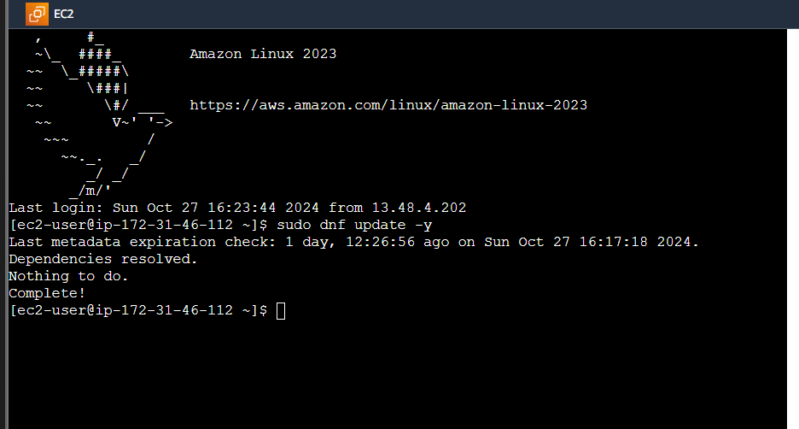

**Step 10 : cd into project directory and run the application**

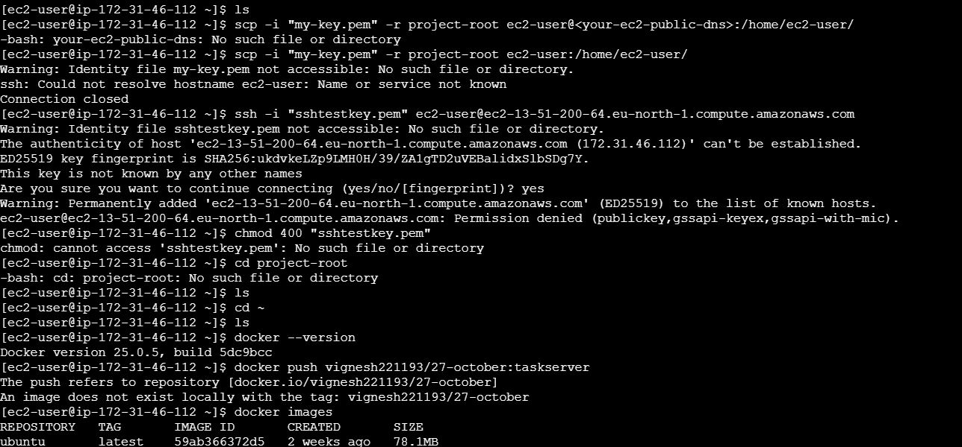

**Finally, localhost into the website**

